|  |  |  |
| --- | --- | --- |
| **Credit Hours System**  **GENN004**  **MATLAB** |  | **Cairo University**  **Faculty of Engineering** |

Final Assessment

Research Project #4

Pharmacy Management System

**Submitted to:** Dr. Sahar Fawzi

**Name:** Ali Mohamed Aly Gad Hashish

**ID:** 1190223

**E-Mail:** [Ali.Hashish001@gmail.com](mailto:Ali.Hashish001@gmail.com)

The program represents a pharmacy management system. It is built around the usage of three tables, with each table having a set of vital information regarding the pharmacy. As table 1 contains the drug ID and the price, while table 2 contains the customer ID, their total amount of all previous orders, as well as their total drug number of all previous orders. As for table 3, it contains the customer ID, drug ID and discount percentage.

The program provides a simple easy-to-use interface that enables the user to utilize the program efficiently, without the need of external assistance. This leads to the user’s comfort.

1. 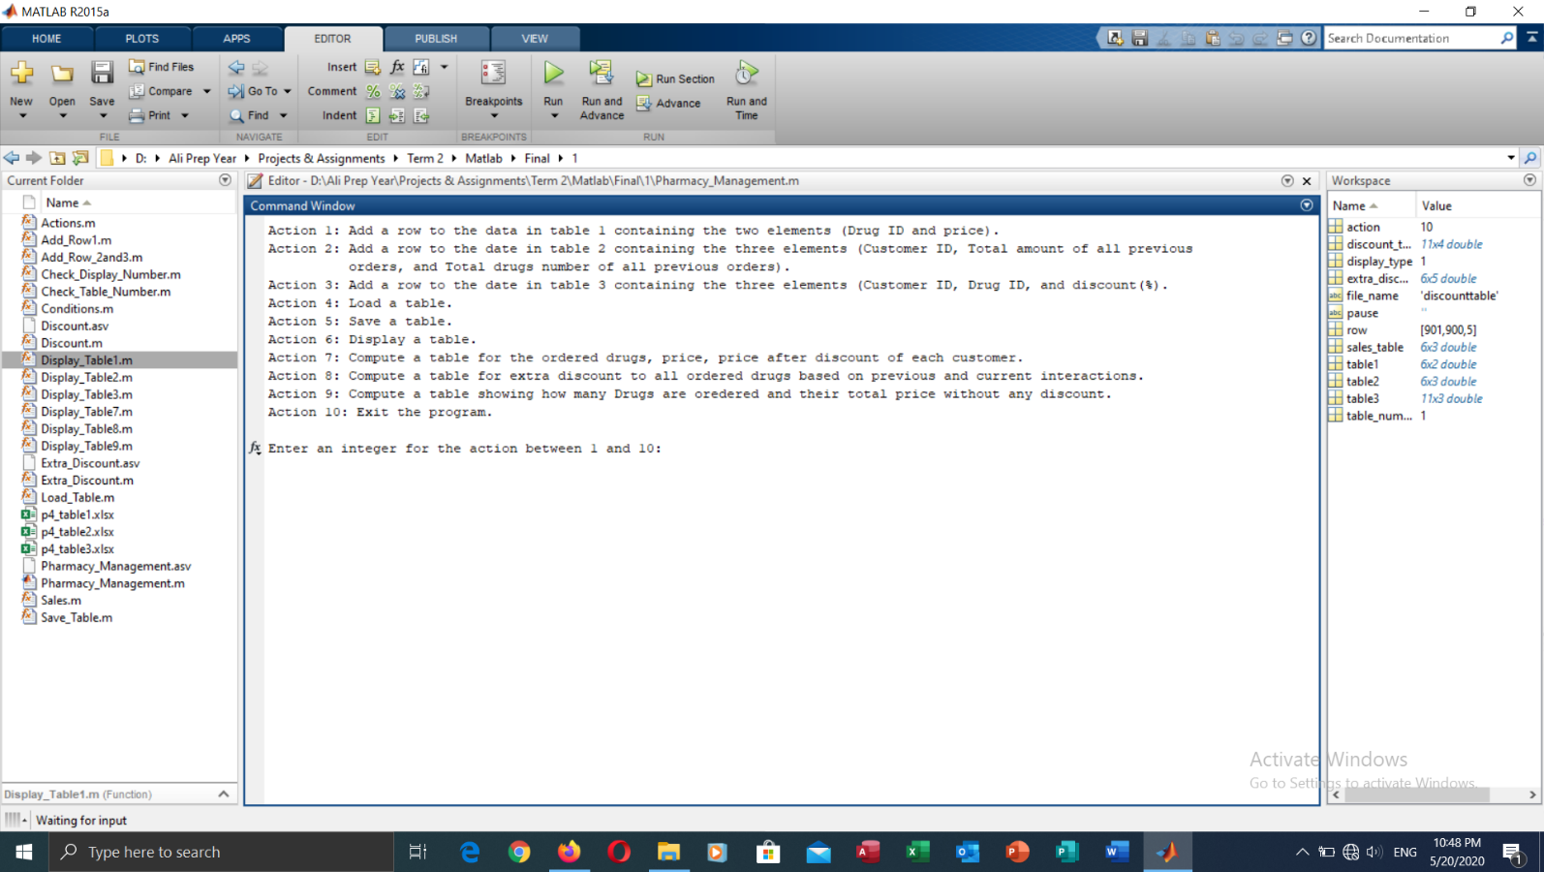On initially running the program, a menu of 10 options appears to the user to choose from.
2. 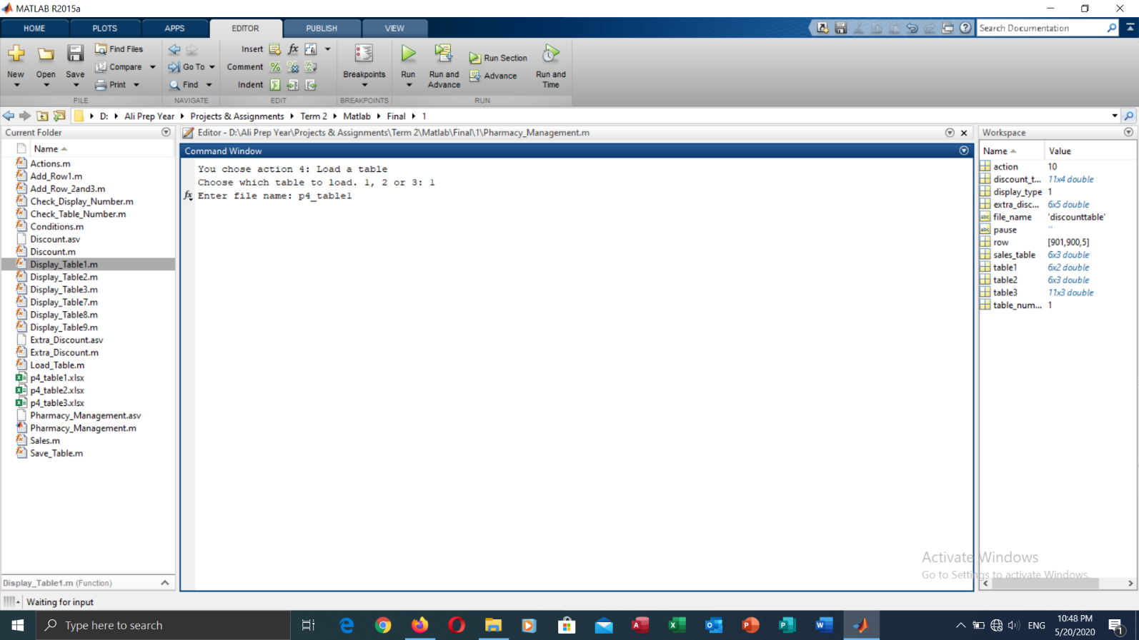Most of the times, the user already has prepared tables on their computer. Therefore, the program allows the user to load these tables by choosing Action 4. On choosing this option, the user is asked which table they would like to load (from the aforementioned tables). Then they are asked for the file’s name to be loaded.
3. 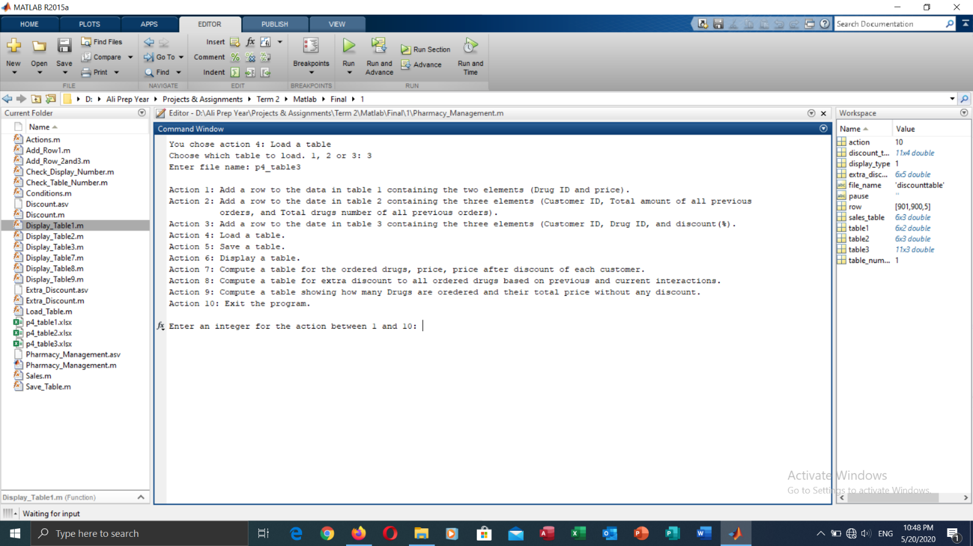Having loaded the tables, the user is showed to the main menu again, where they are asked which action they would like to take again.
4. 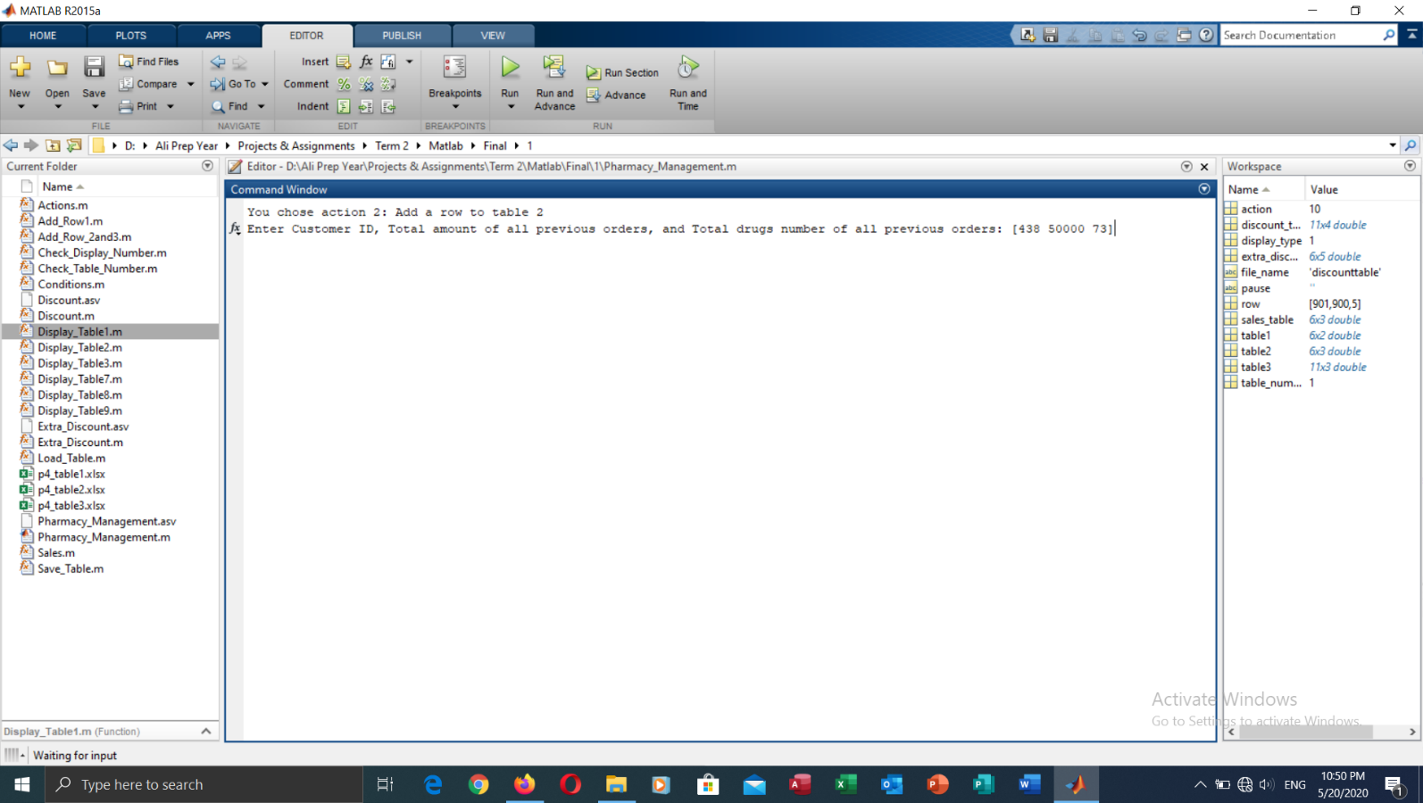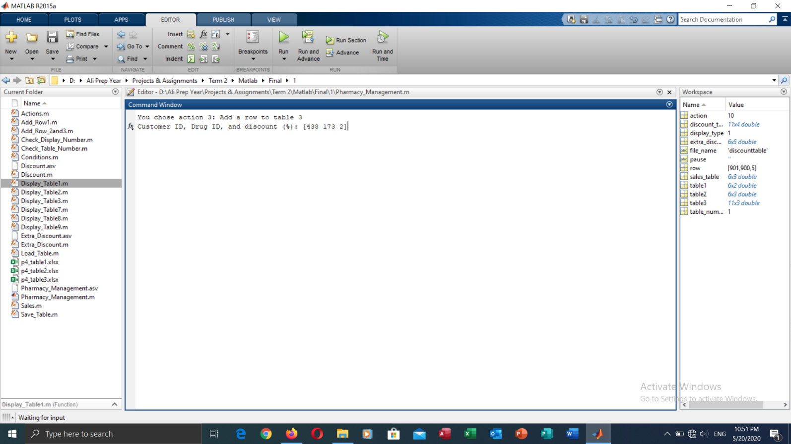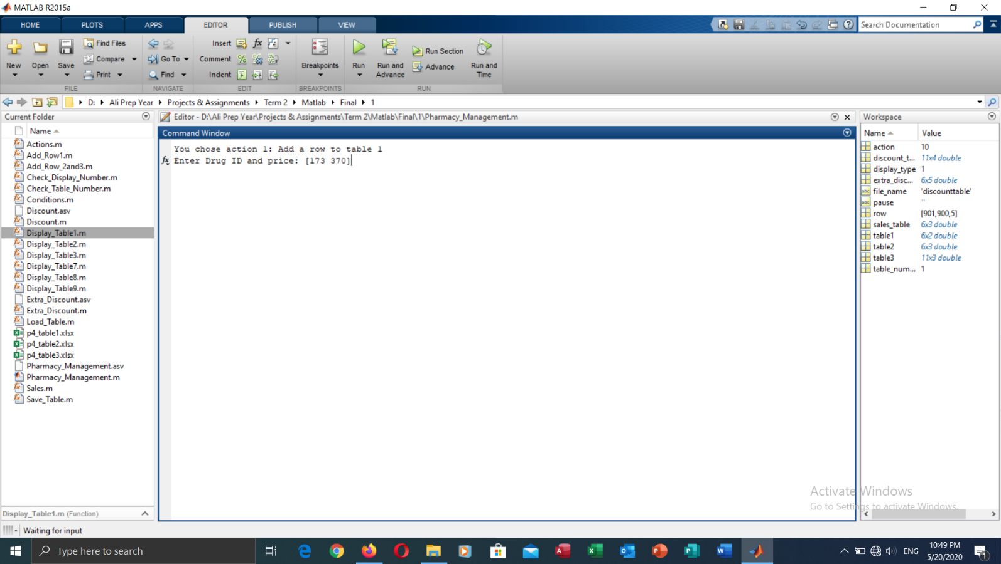The user can also add rows to a certain table, or make up their own table from scratch by continually adding rows to said table. Of course, the program always checks that the user chose a valid number for the table, and that they entered the right number of columns for each table, or else the user is asked to re-enter the data.
5. 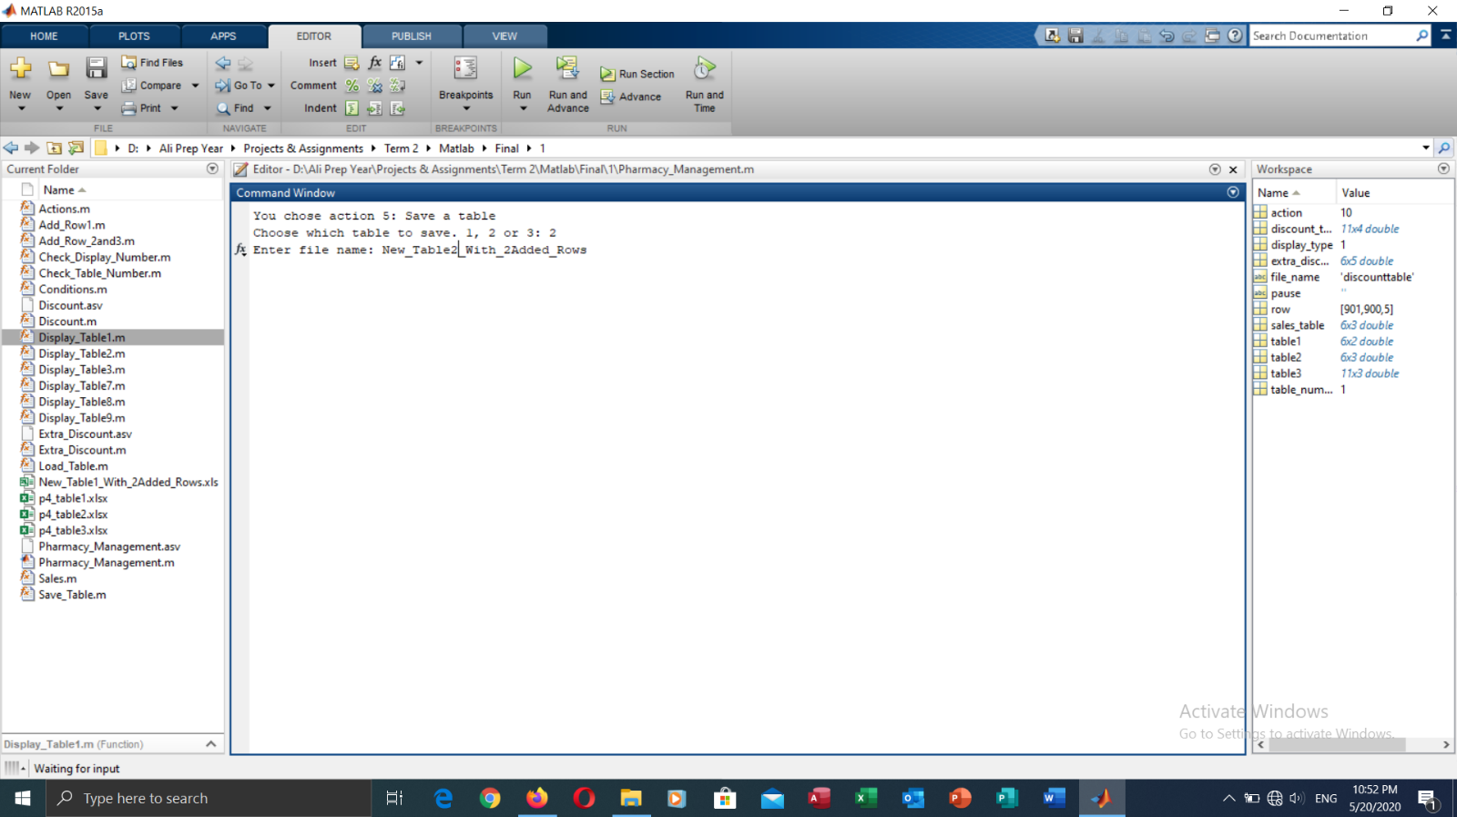After each option, the user is returned to the main menu again, as previously mentioned. And now, after adding a few rows to a few tables, the user might want to save their tables. They can easily do that using Action 5, where the number of the table is prompted from the user, as well as the name of the file that it will be saved with.
6. 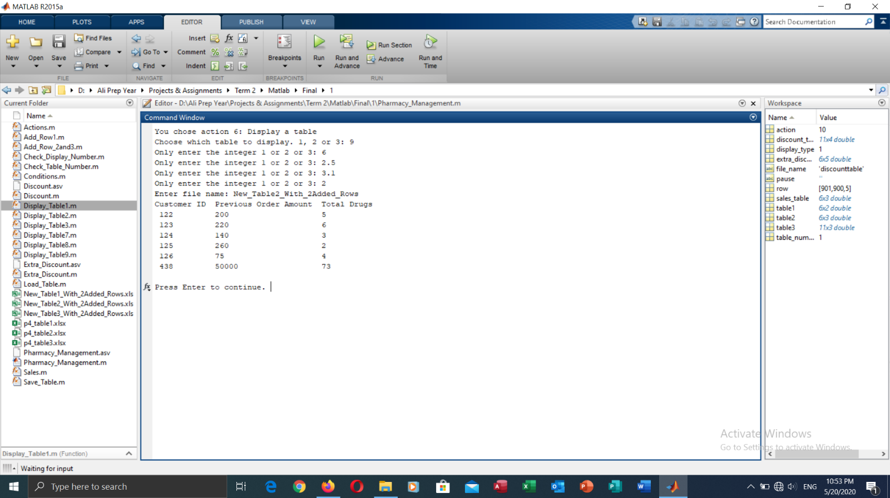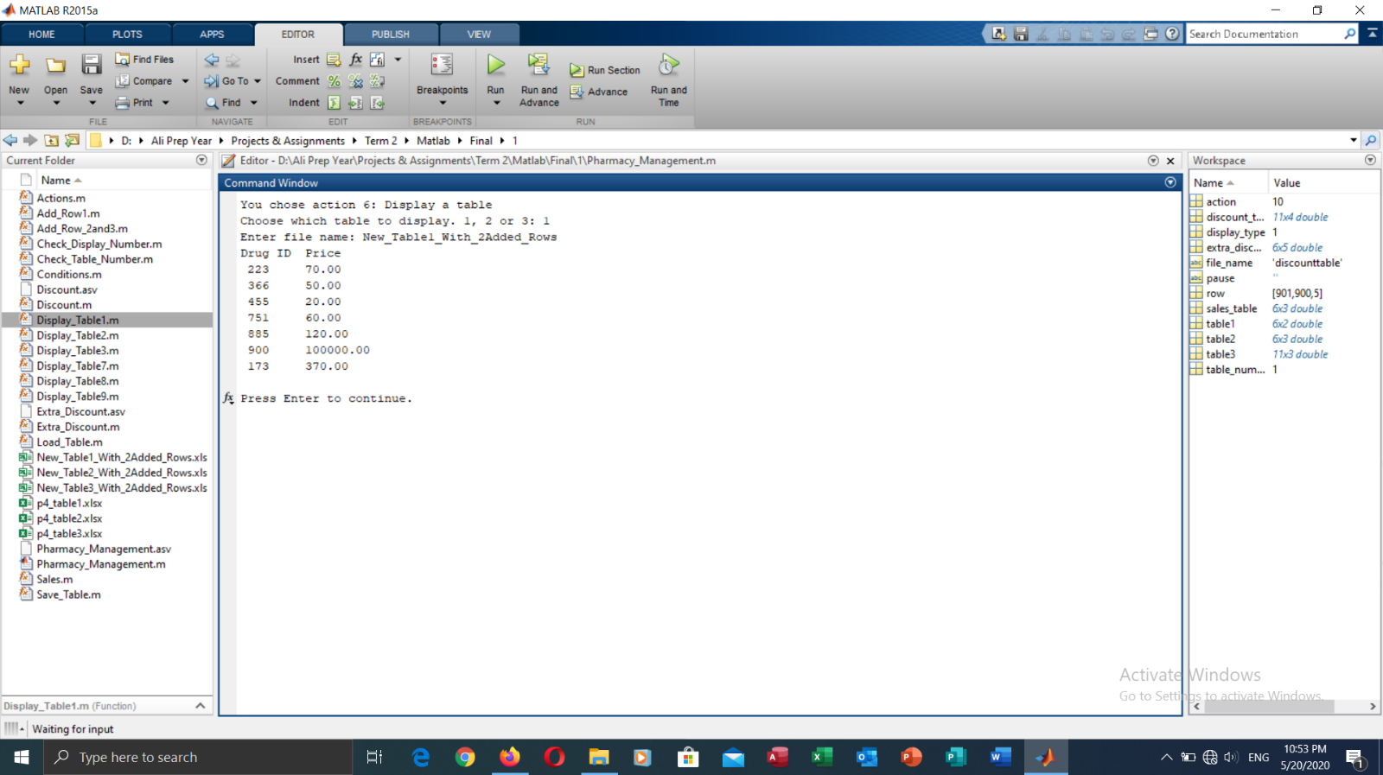The user might want to display a specific table at some point, to check its data and revise it, if so, they are to choose Action 6 and simply enter the number of the table. The number is checked to see whether it is valid or invalid, then the table is displayed. The user is shown the message “Press Enter to continue.”, this message is to give time for the user to check the table, before proceeding to the main menu yet again.

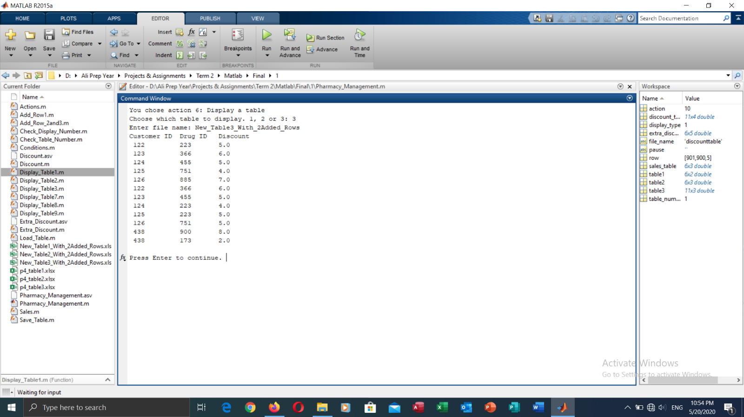

1. 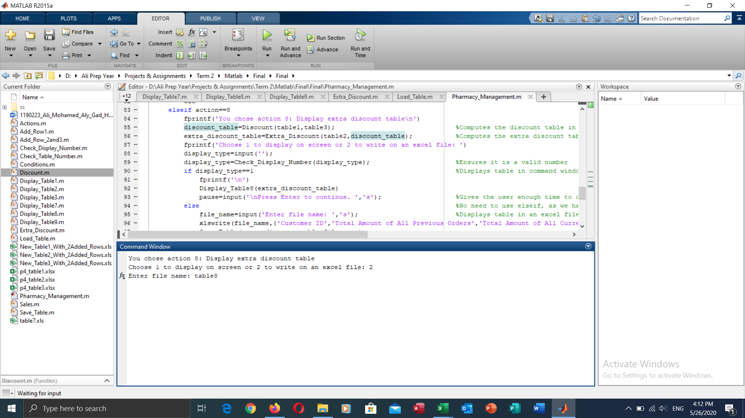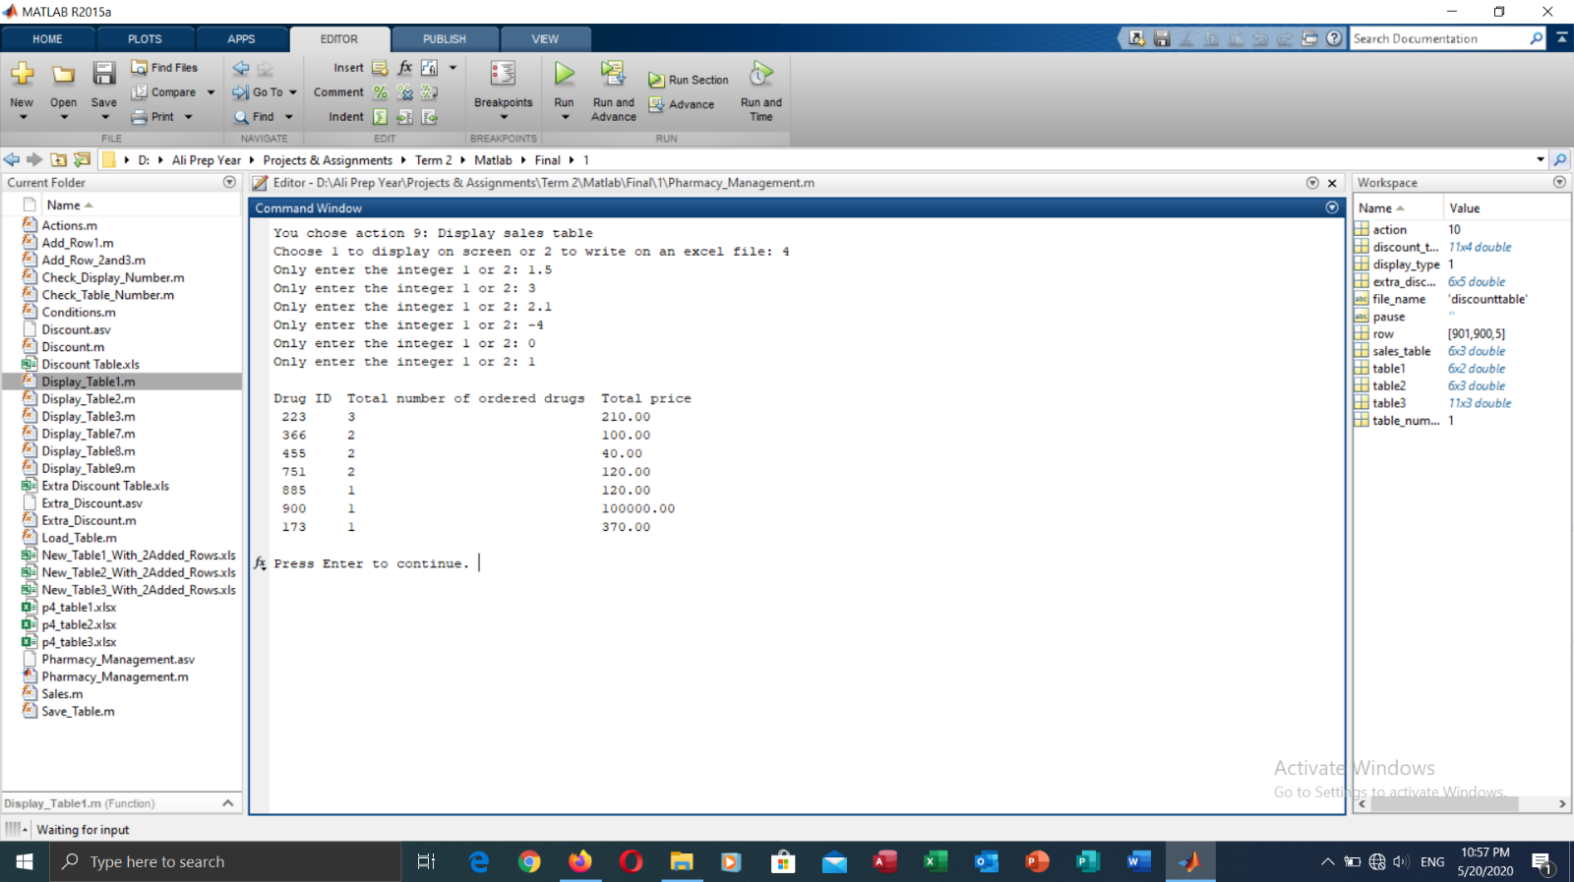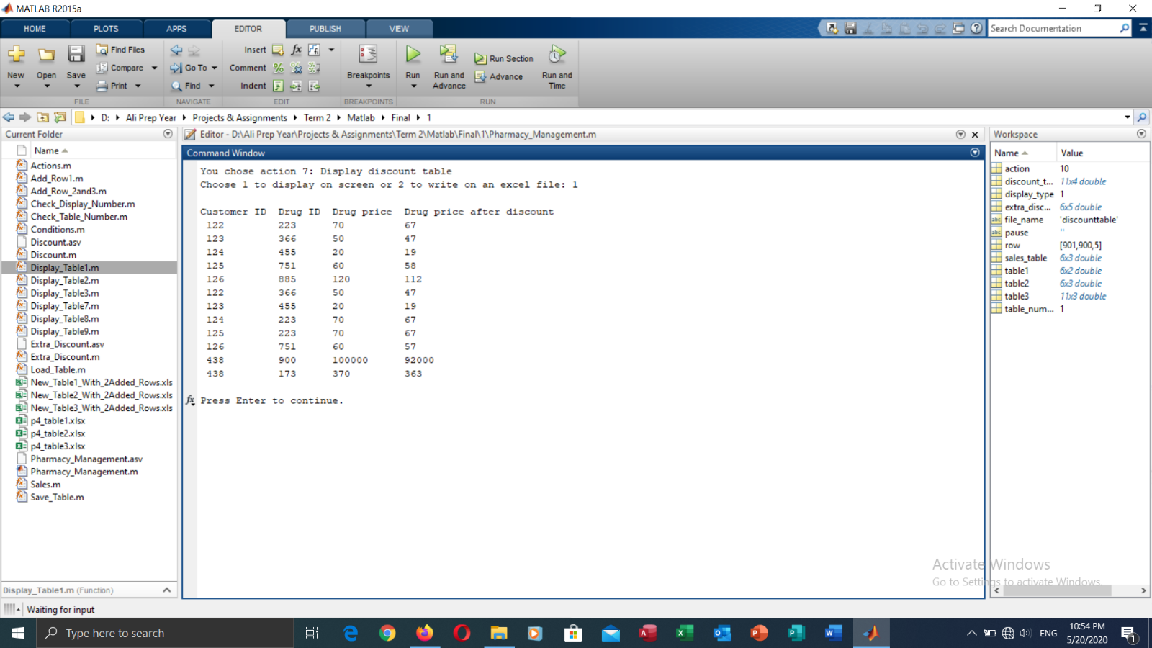The Actions 7 to 9 are for computing new tables that help in managing the pharmacy, as table 7 computes the discounts, and the price after the discount. As for table 8, it is the extra discount table that calculates the extra discounts offered to a customer based on their previous interactions with the pharmacy, as well as their current interactions. The method used in calculating this discount is explained at the end of the report. Table 9 is the sales table, the table that contains the number of ordered drugs and their total prices without the discounts. This helps the manager to check which drug is sold more than the other, to determine which drug to order more from and which to order less from, depending on the supply and demand. When the user chooses one of these three actions, they are asked in the sub menu whether they want the table displayed in the command window, or through an excel file. A function is used to check that the user chooses only one of these options and not another. Also, after the action is processed, the user is asked to press enter to return to the main menu again.
2. 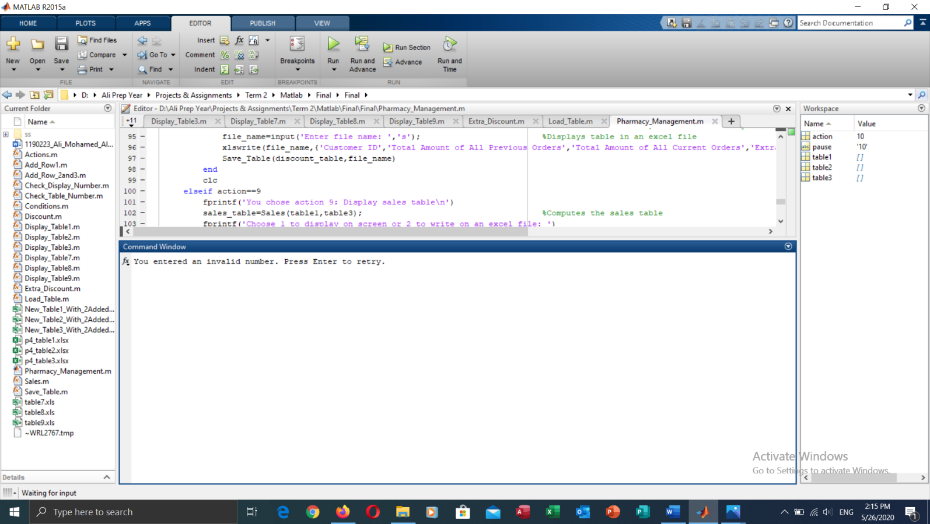In case the user chooses an invalid action, they are shown an error message, and asked to press enter to proceed to the main menu again.
3. 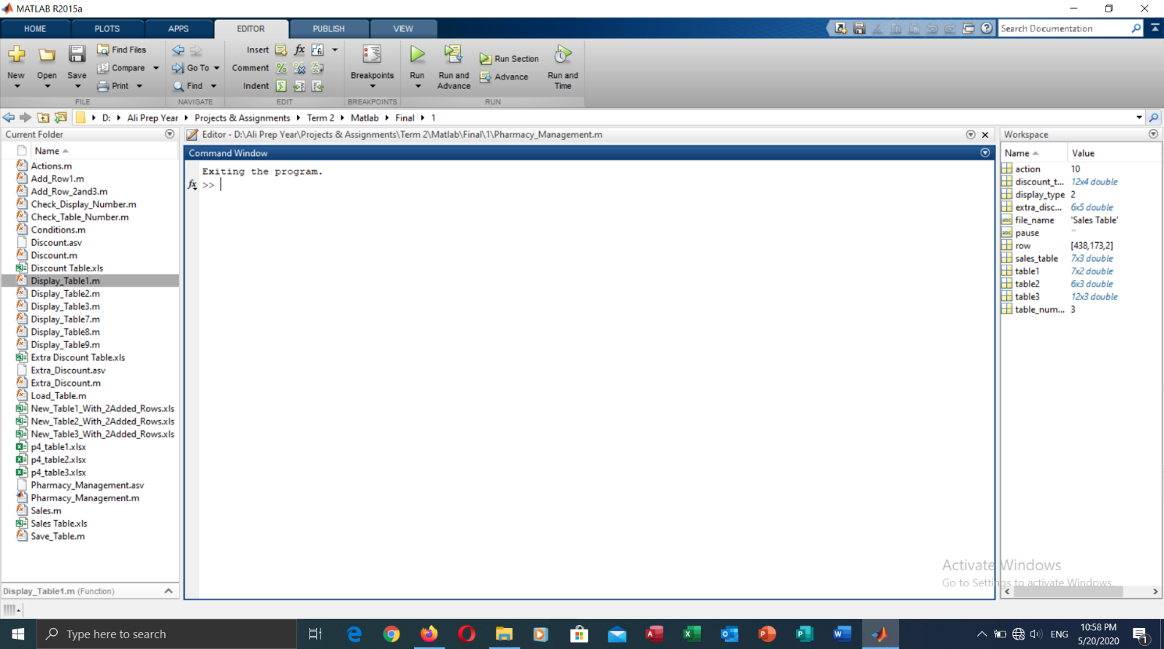Finally, when the user chooses action 10 to exit the program, a short message appears, indicating the end of the program.

Now, as for the extra discount calculation method, it was based on the customer’s previous purchases, and their current purchases, where a discount is given for each based on the amount paid, then both discounts are added to get the total extra discount for each customer.

It is based as such: if the previous purchases are above 200, the customer gets an extra 1% discount. If it reaches or exceeds 1 000, the customer gets a 3% discount. For purchases that are 3 000 or more, the customer gets a 5% discount. And if the previous purchases exceed 10 000, a 10% extra discount is given. These are the ones based on the previous purchases, as for the ones based on the current purchase, if that purchase reaches or surpasses 250, the customer gets an additional 2% discount, if it is greater than or equal to 500, an additional 5% discount is given. And finally, if the current purchases reach or exceed 1 000, the customer gets an extra 10% discount.

The total discount is the addition of the discounts from the previous purchases, and the discount from the current purchases. So, for instance, if a customer always visits the pharmacy, and has amassed 6 000 for previous purchases – which gives a 5% discount – and their current order is worth 1 200 – which results in 10% discount. The total extra discount sums up to 10 + 5 which gives a 15% extra discount.

The following table illustrates more examples to further clarify the method of calculation of the extra discount.

|  |  |  |  |  |
| --- | --- | --- | --- | --- |
| Amount of Previous Orders | Previous Order’s Discount | Amount of Current Orders | Current Order’s Discount | Total Extra Discount |
| 980 | 1% | 633 | 5% | 6% |
| 17 420 | 10% | 340 | 2% | 12% |
| 0 | 0% | 1 857 | 10% | 10% |
| 4 673 | 5% | 175 | 0% | 5% |
| 1 250 | 3% | 891 | 5% | 8% |
| 223 | 1% | 50 | 0% | 1% |

As such, the highest extra discount attainable would be 20%, which is only offered to special customers whose previous purchases have exceeded the 10 000 mark, and their current order surpass 1 000. This is made to show the customer how much they mean to the pharmacy, and even treat them as a VIP.